Practical-5 Replication

Aim - Implementation of Replicas in MongoDB.

**Summary:**

Replication is the process of synchronizing data across multiple servers.

Replication is referred to the process of**ensuring that the same data is available on more than one Mongo DB Server.** This is sometimes required forthe purpose of increasing data availability. Replication provides redundancy and increases data availability with multiple copies of data on different database servers. Replication protects a database from the loss of a single server. Replication also allows you to recover from hardware failure and service interruptions. Because if your main MongoDB Server goes down for any reason, there will be no access to the data. But if you had the data replicated to another server at regular intervals, you will be able to access the data from another server even if the primary server fails.

# Example how to Set Up a Replica Set

Step 1:

Shutdown already running MongoDB server.

Step 2:

Create 3 folders with name data1,data2,data3 at any location.

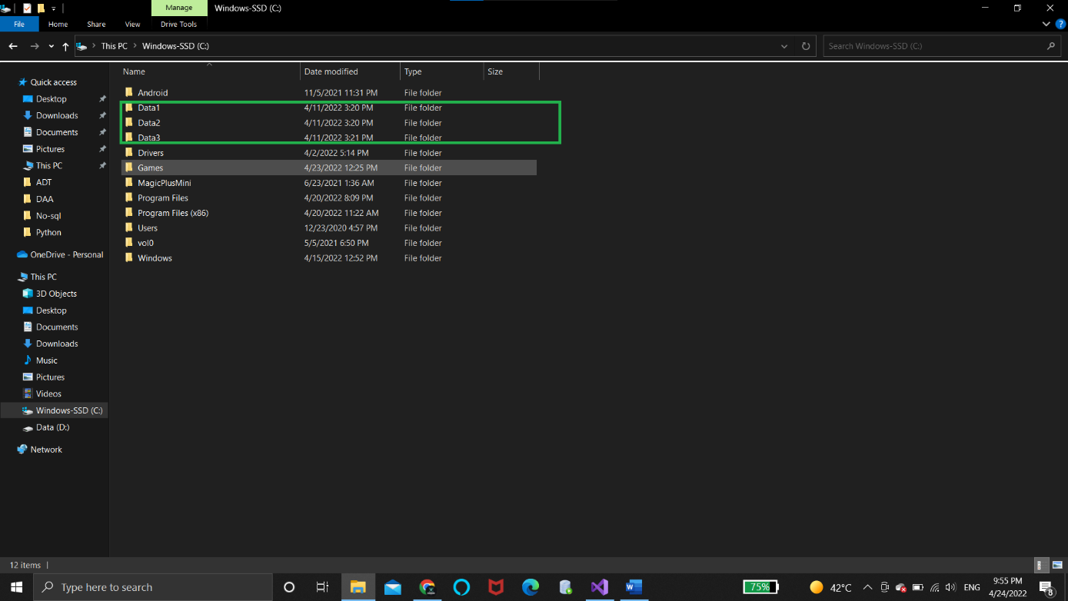

Step 3: (Creating Primary instance)

First change the cmd path.

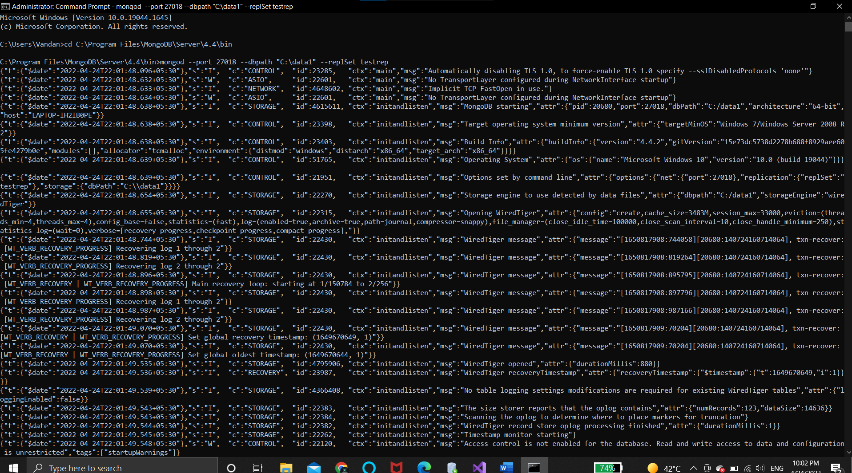

Start MongoDB server and write the following query with proper file path.

mongod --port "PORT" --dbpath "YOUR_DB_DATA_PATH" --replSet

"REPLICA_SET_INSTANCE_NAME"6

mongod --port 27018 --dbpath "C:\data1" --replSet testrep

C:\>mongo --port 27018

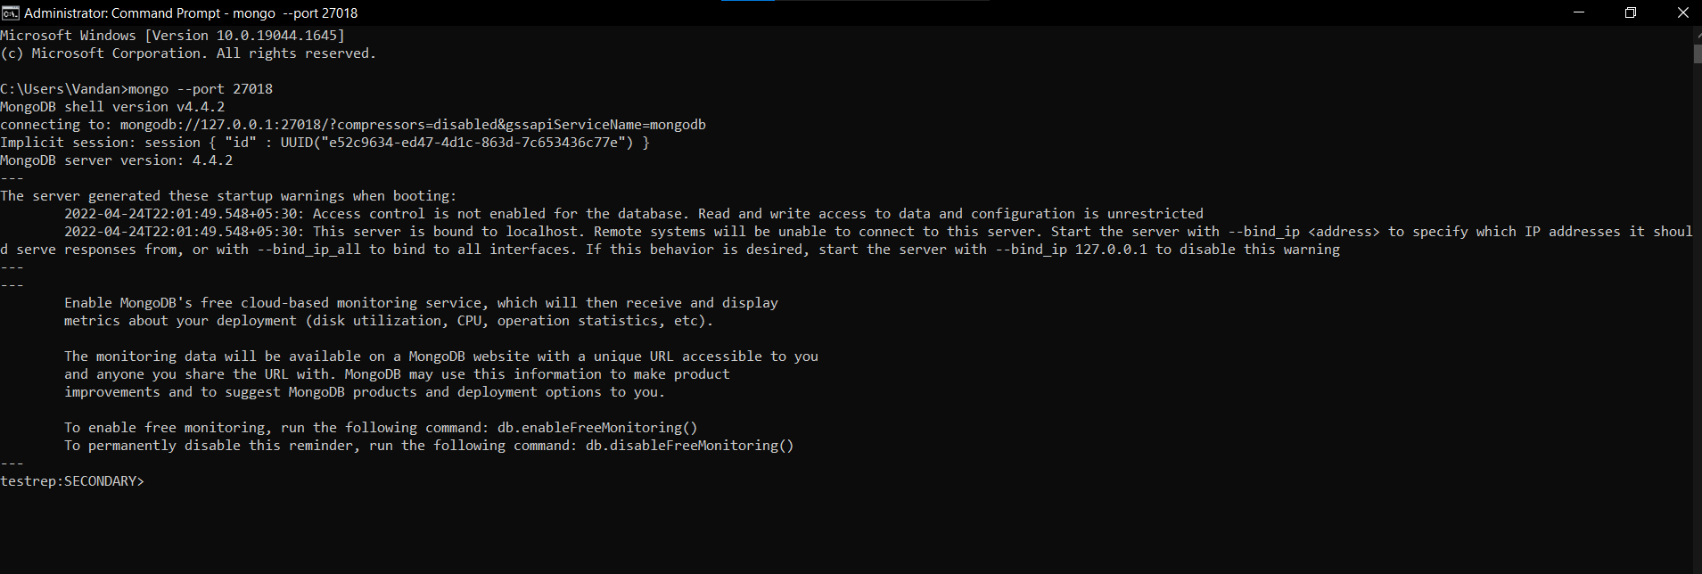

Step-4

Open another cmd and in that write the following query.

First change the cmd path.

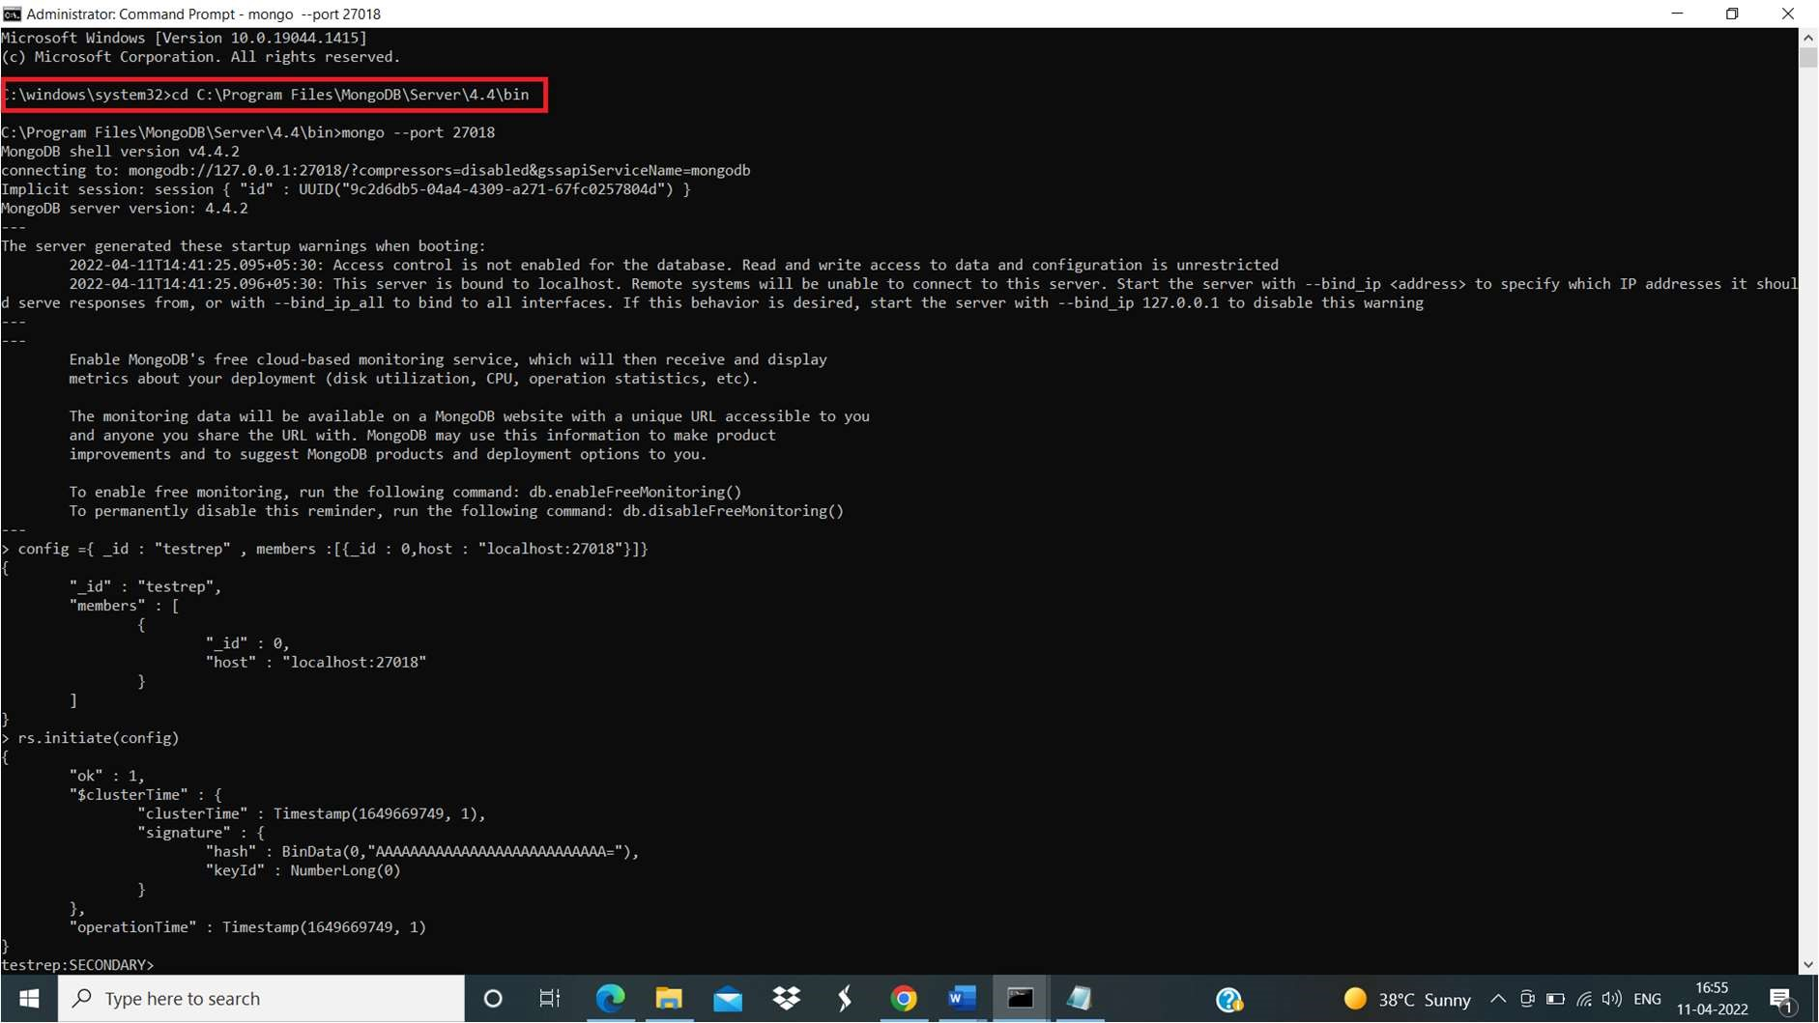

mongo --port 27018

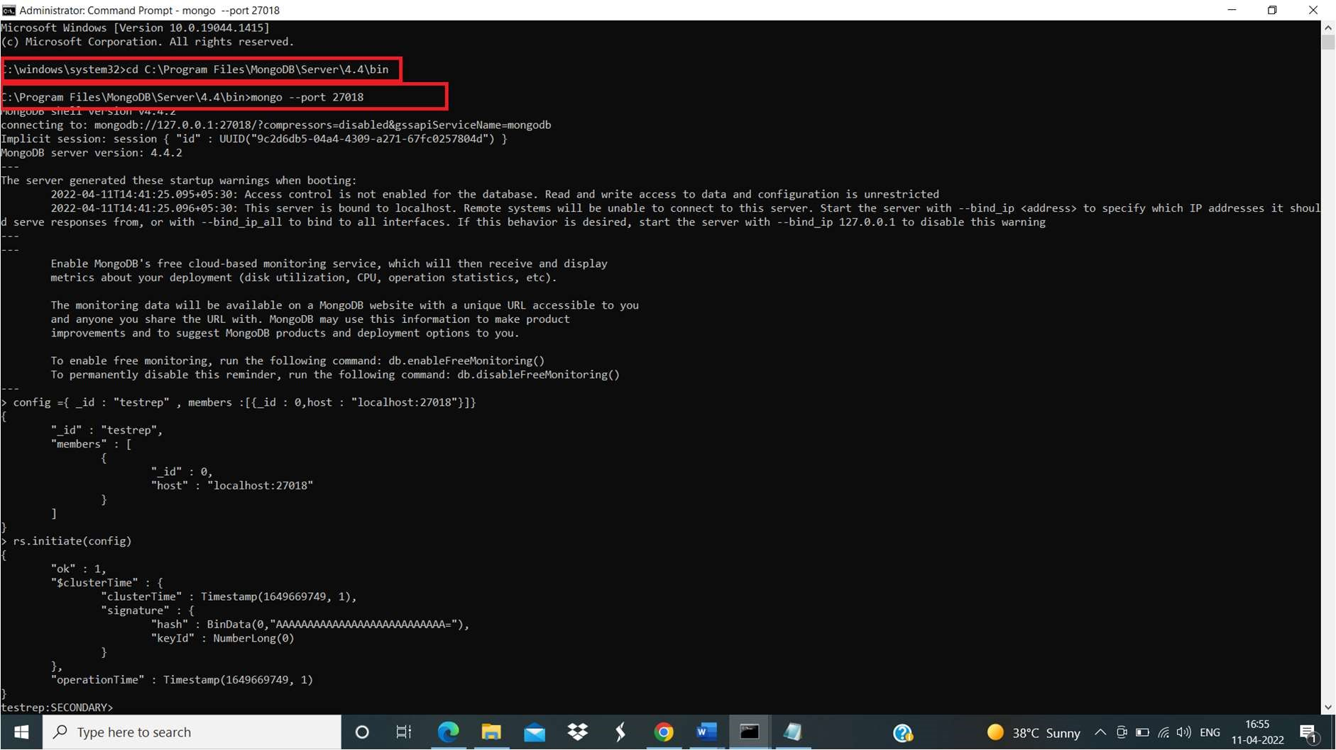

Now our primary server is running on port 27018.

• Now repeat step on 3 for starting secondary server but this time we have to give file path of folder data2/data3 we made earlier

And in other terminal write following query mongo -port 27019.

First change the cmd path.

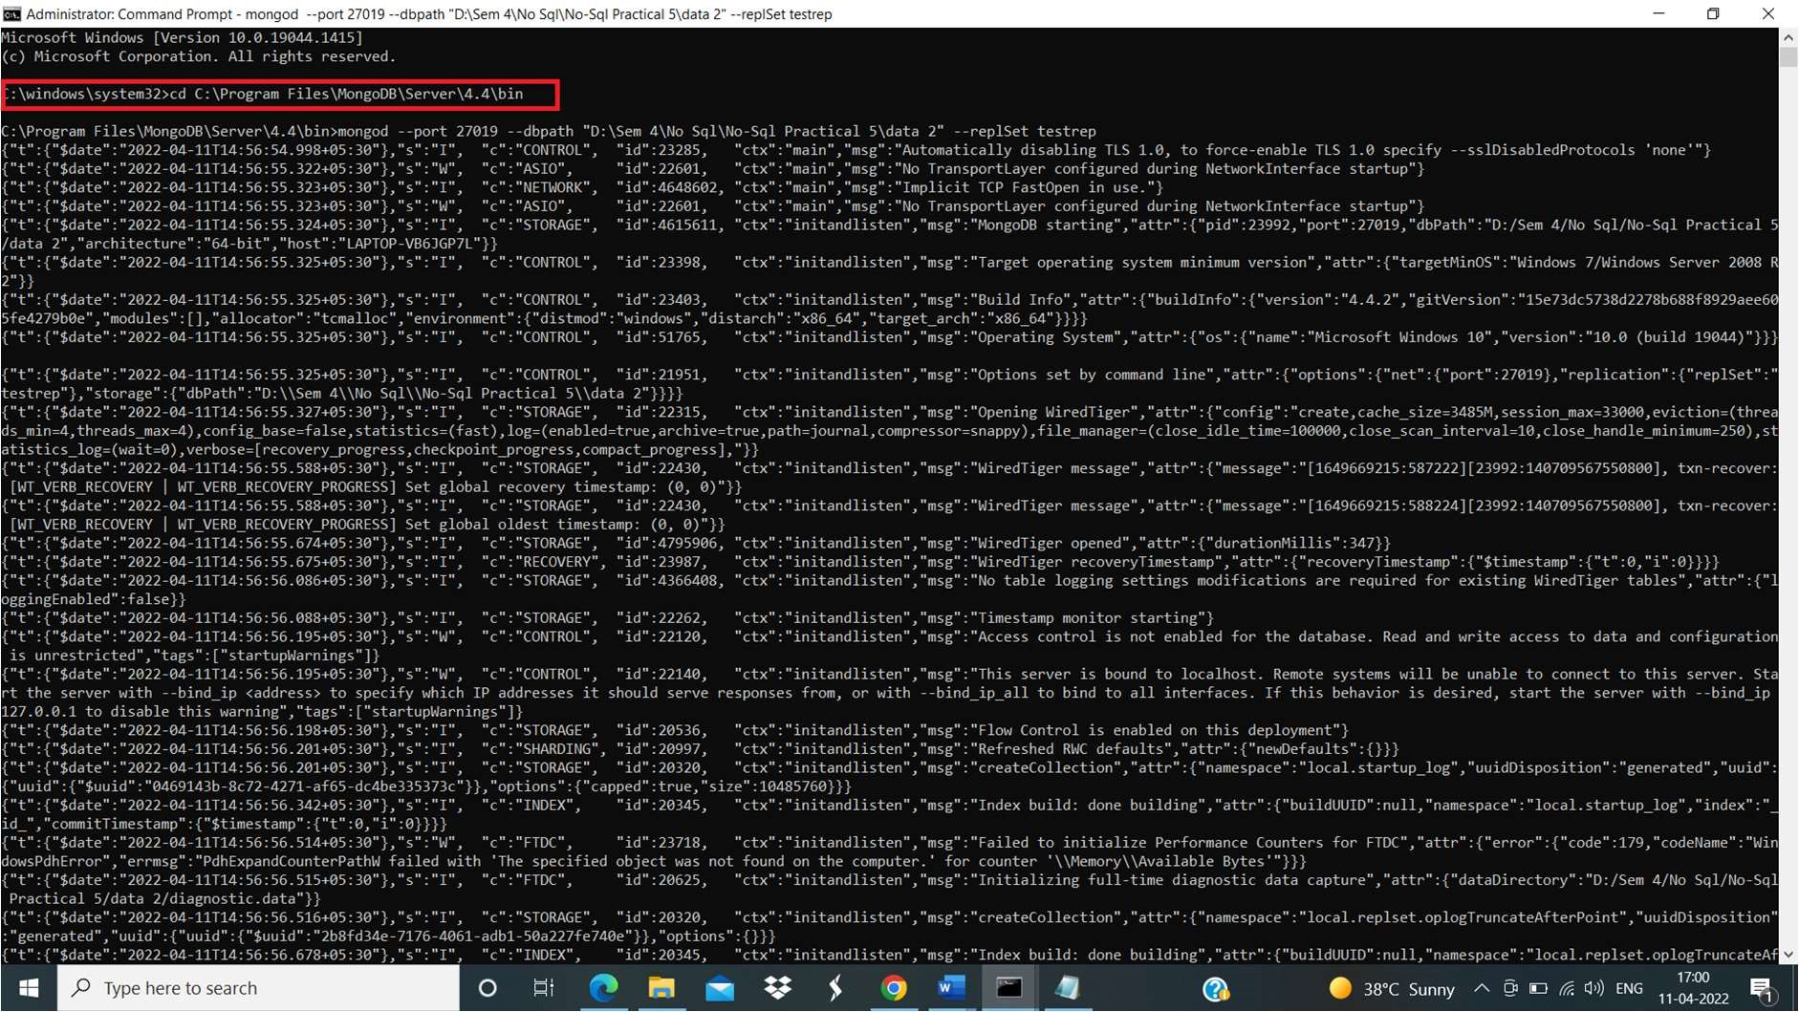

mongod --port 27019 --dbpath "D:\Sem 4\No Sql\No-Sql Practical 5\data 2" --replSet testrep

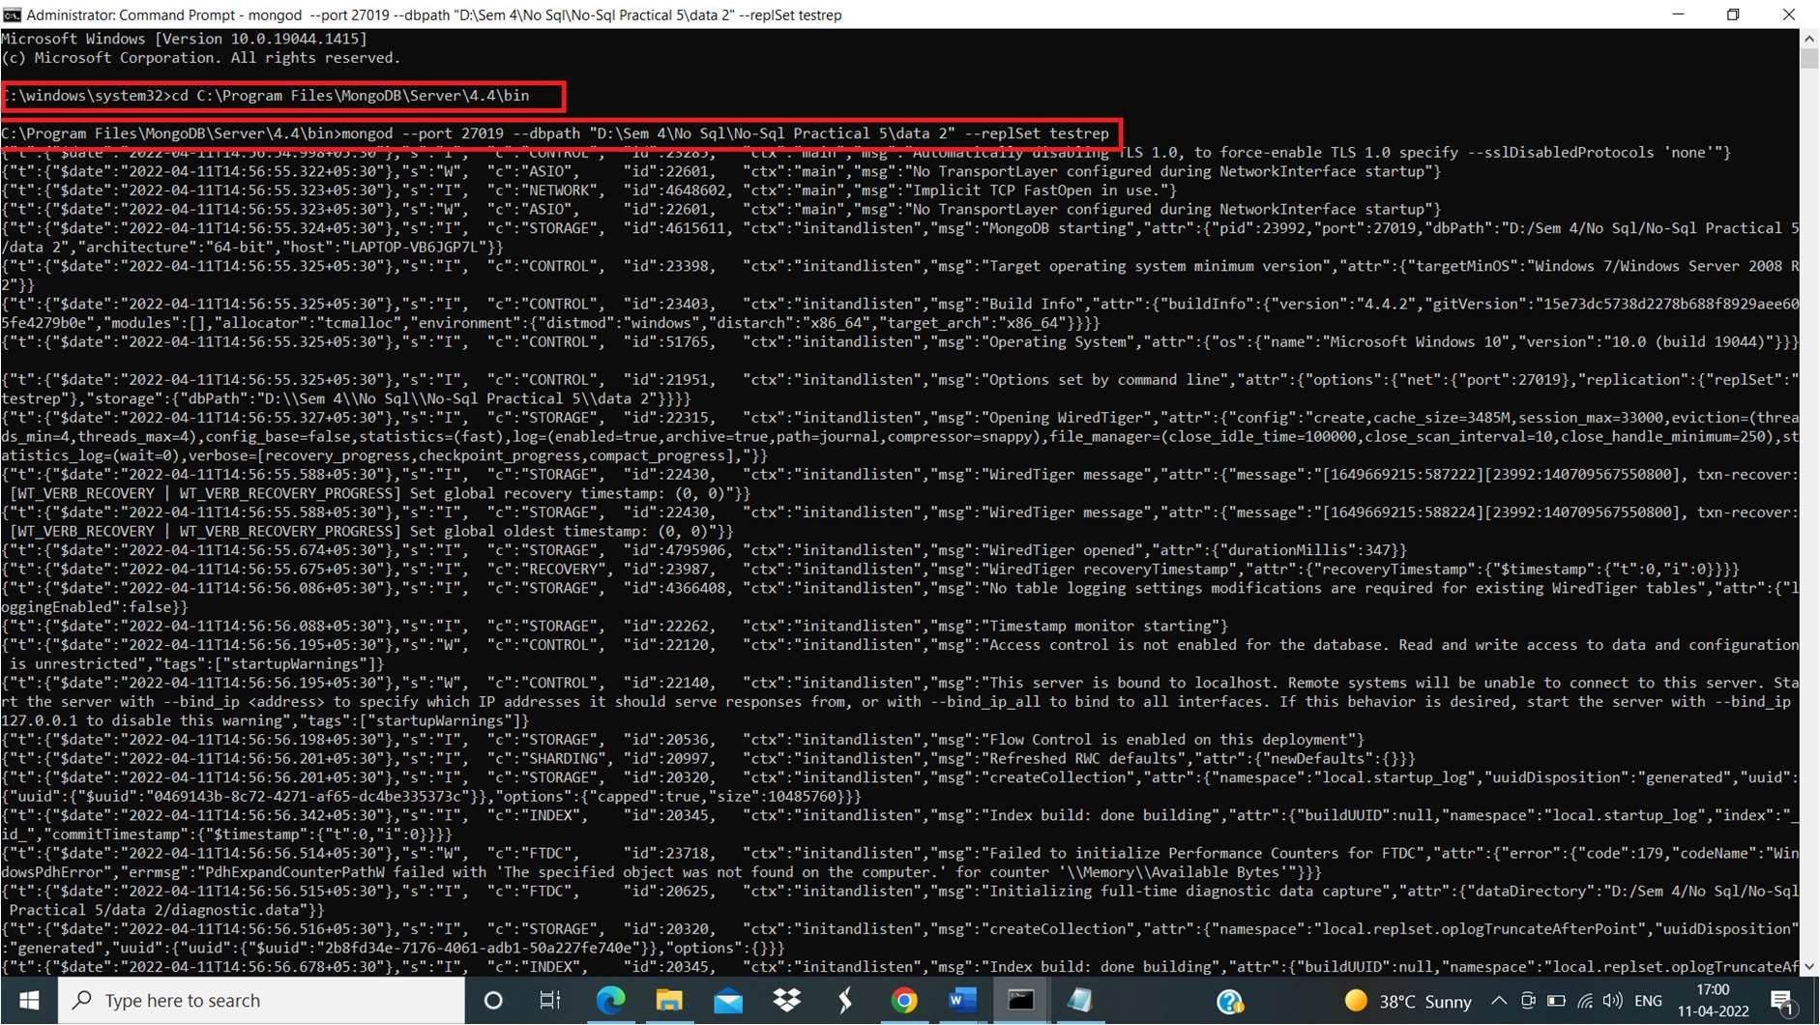

Now Open another command prompt for client. We will use this window to query our second server instance

First change the cmd path.

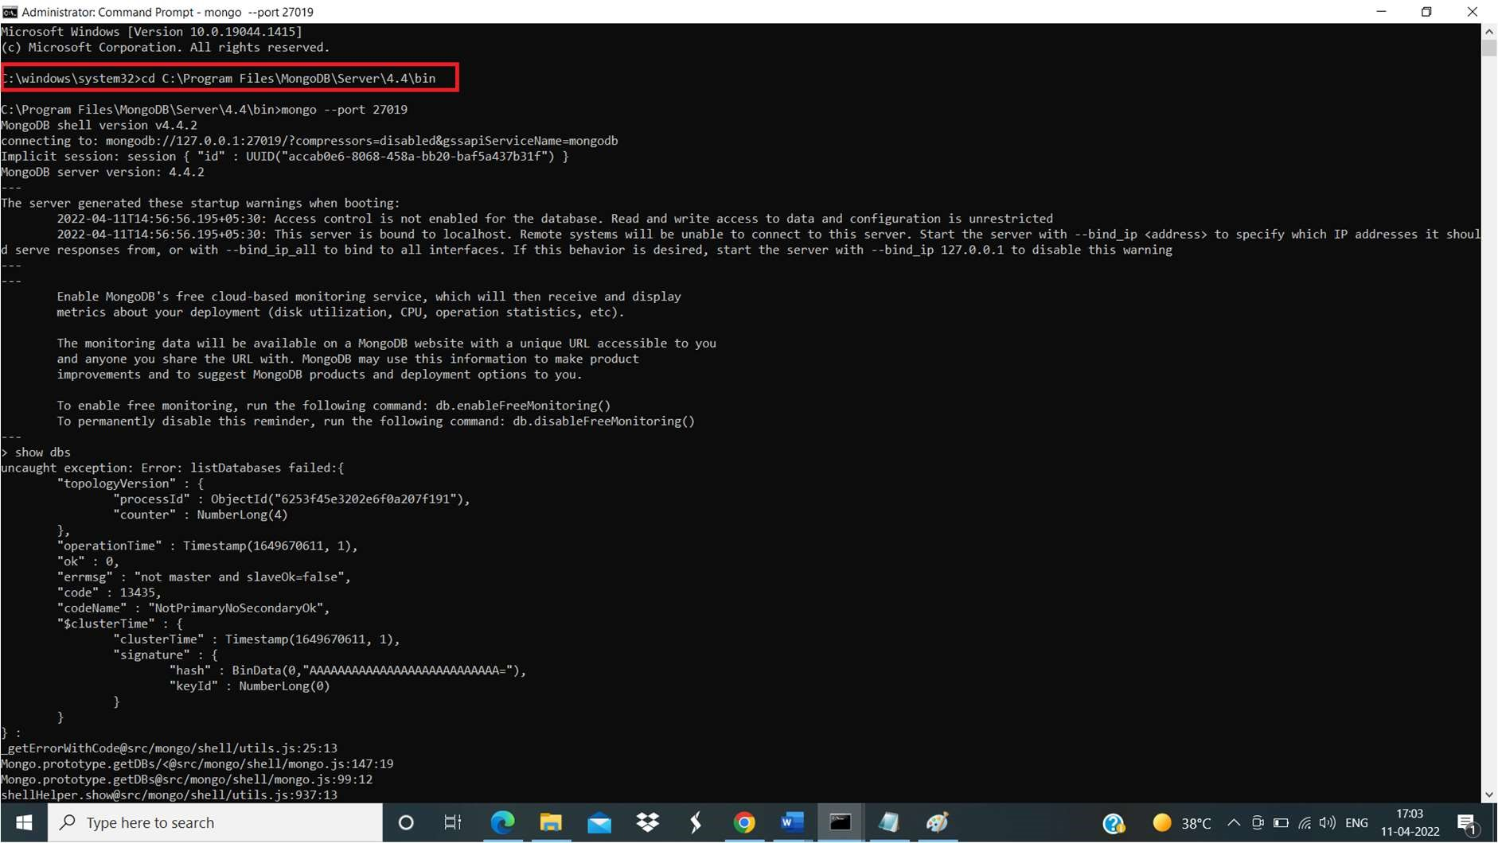

mongo --port 27019

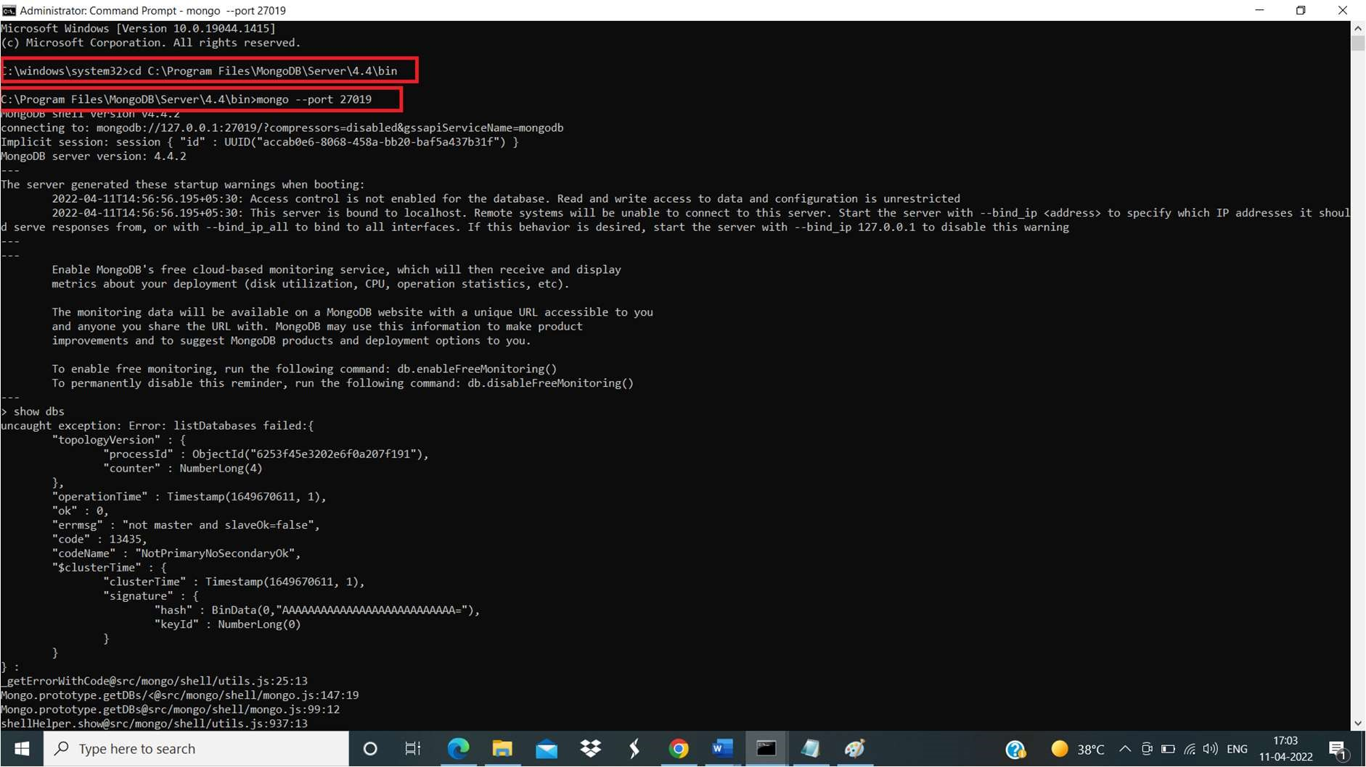

Now Open another command prompt for client. We will use this window to query our second server instance

First change the cmd path.

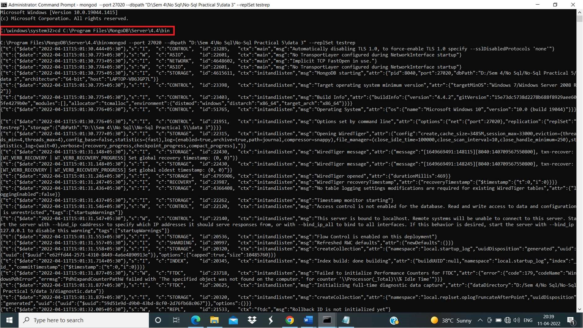

mongod --port 27020 --dbpath "D:\Sem 4\No Sql\No-Sql Practical 5\data 3" --replSet testrep C:\>mongo --port 27020

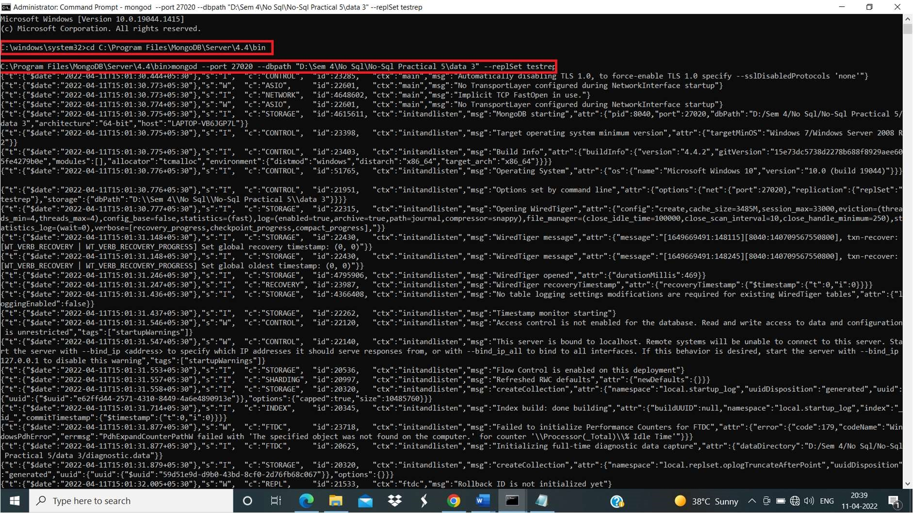

Now Open another command prompt for client. We will use this window to query our second server instance

First change the cmd path.

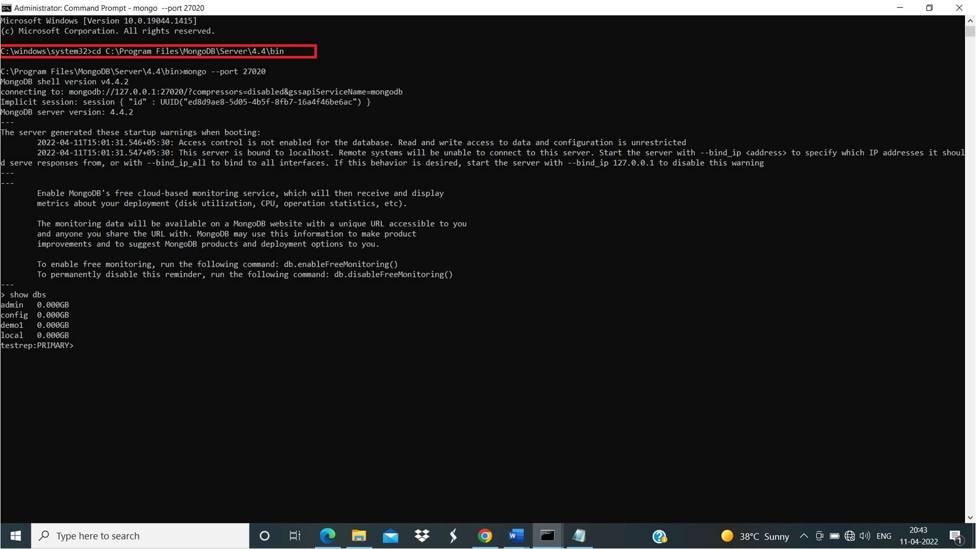

mongo --port 27020

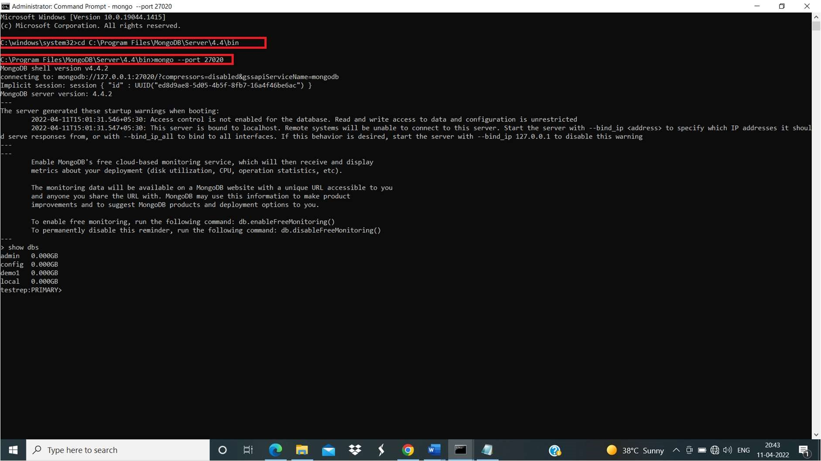

Now we have in total 6 CMDs among them 2 for primary and other pairs for secondary.

Step 5:

Now go to the command prompt of Primary server’s Client instance. Now type the following code

config ={ _id : "testrep" , members :[ { _id : 0, host : "localhost:27018" } ] }

Above code set id=0 to the first replica instance which is on port 27018.(PRIMARY INSTANCE)

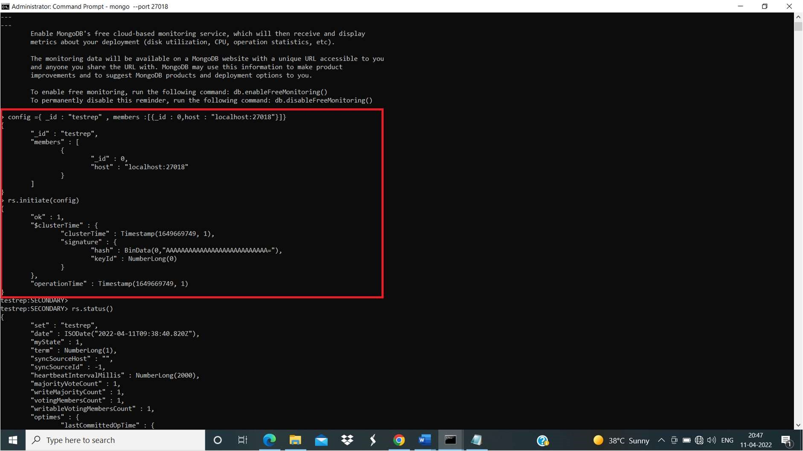

After this write command rs.initiate(config)

This command initiates a replica set with the current host as its only member.

This is confirmed by the output, which should resemble the following:

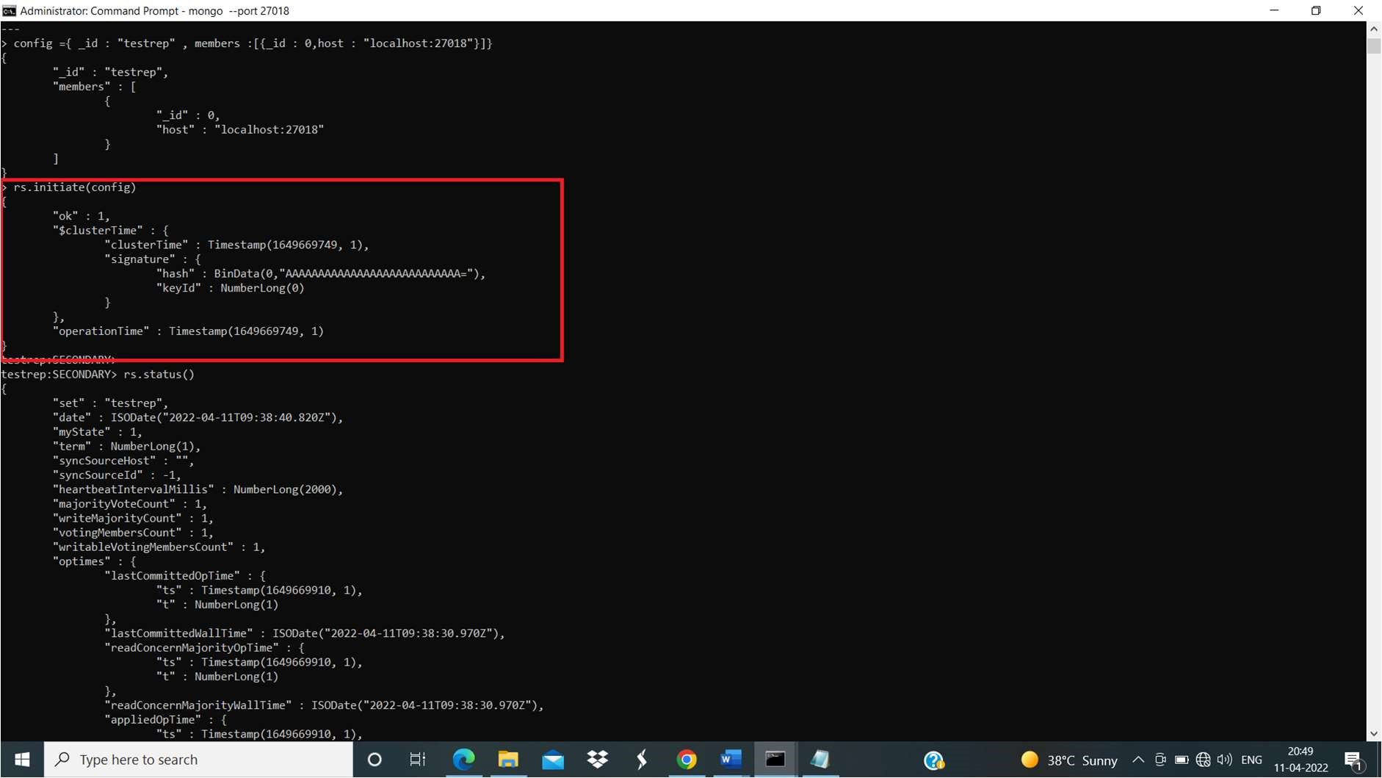

After In primary server’s cmd we have to execute rs.status()query. rs.status()

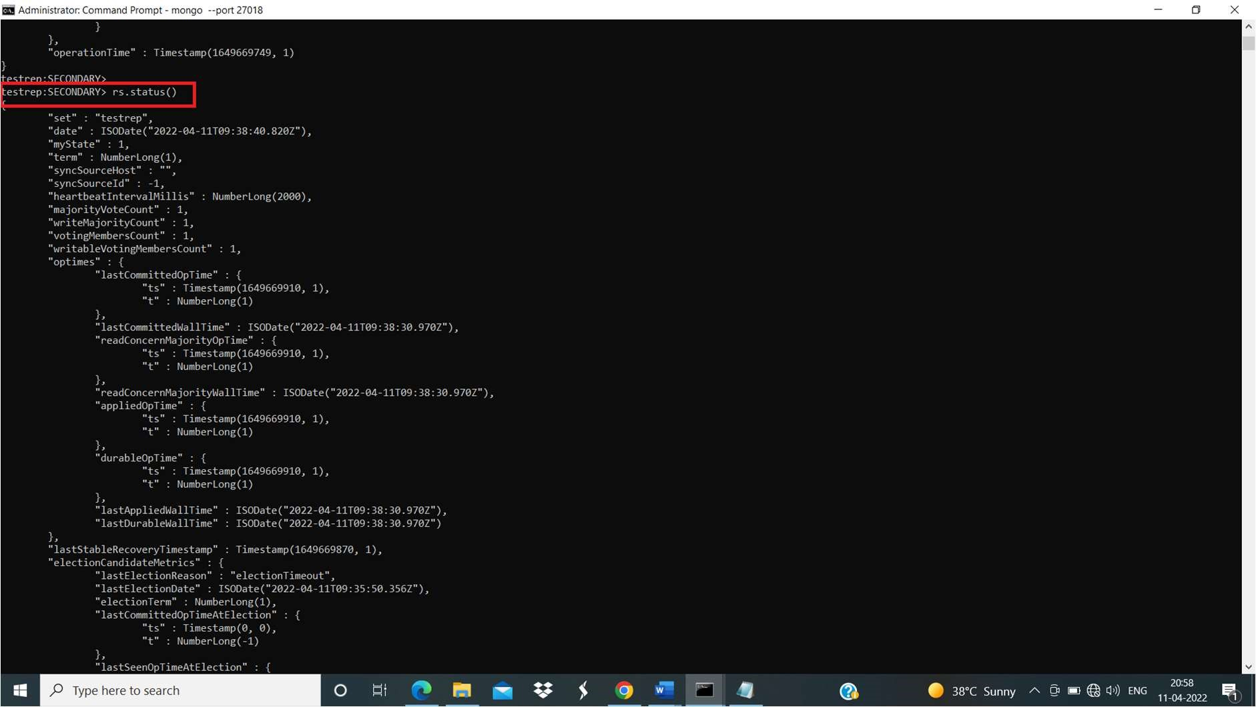

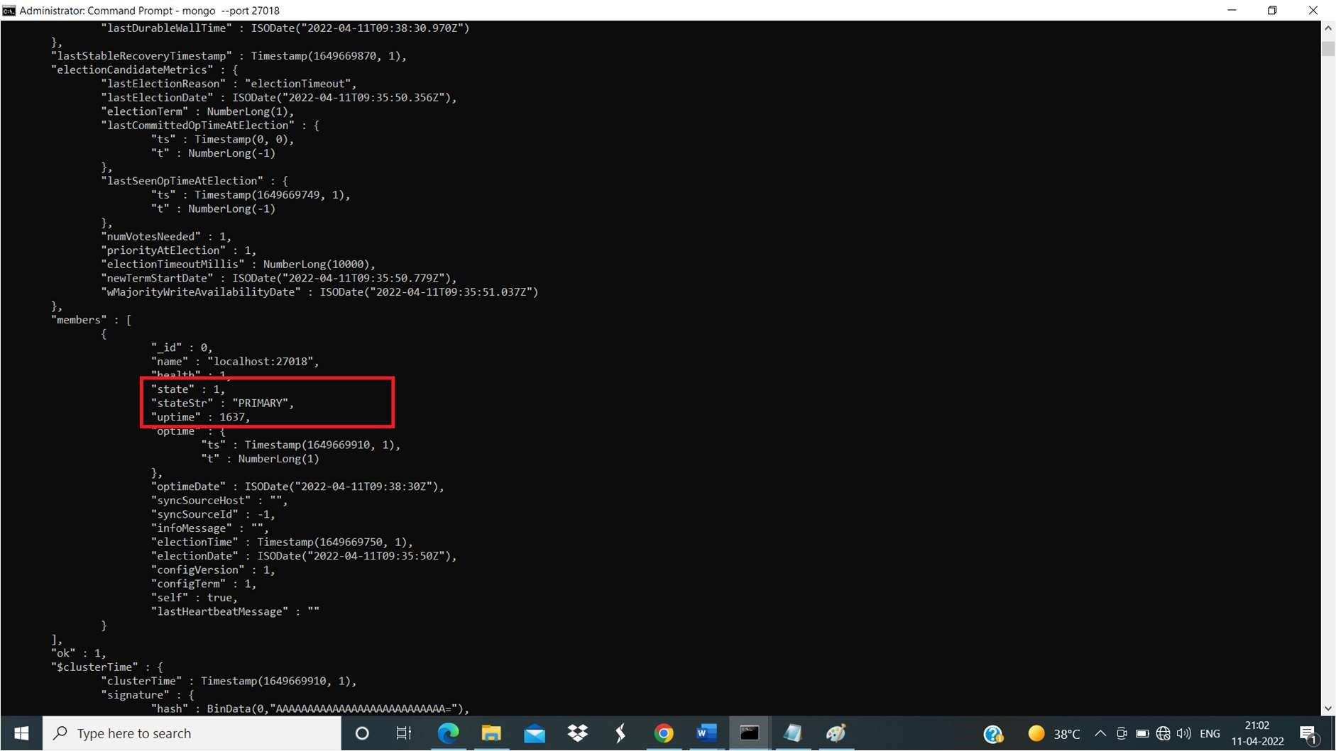

Step 6:

In primary server’s cmd we have to execute rs.add() query.

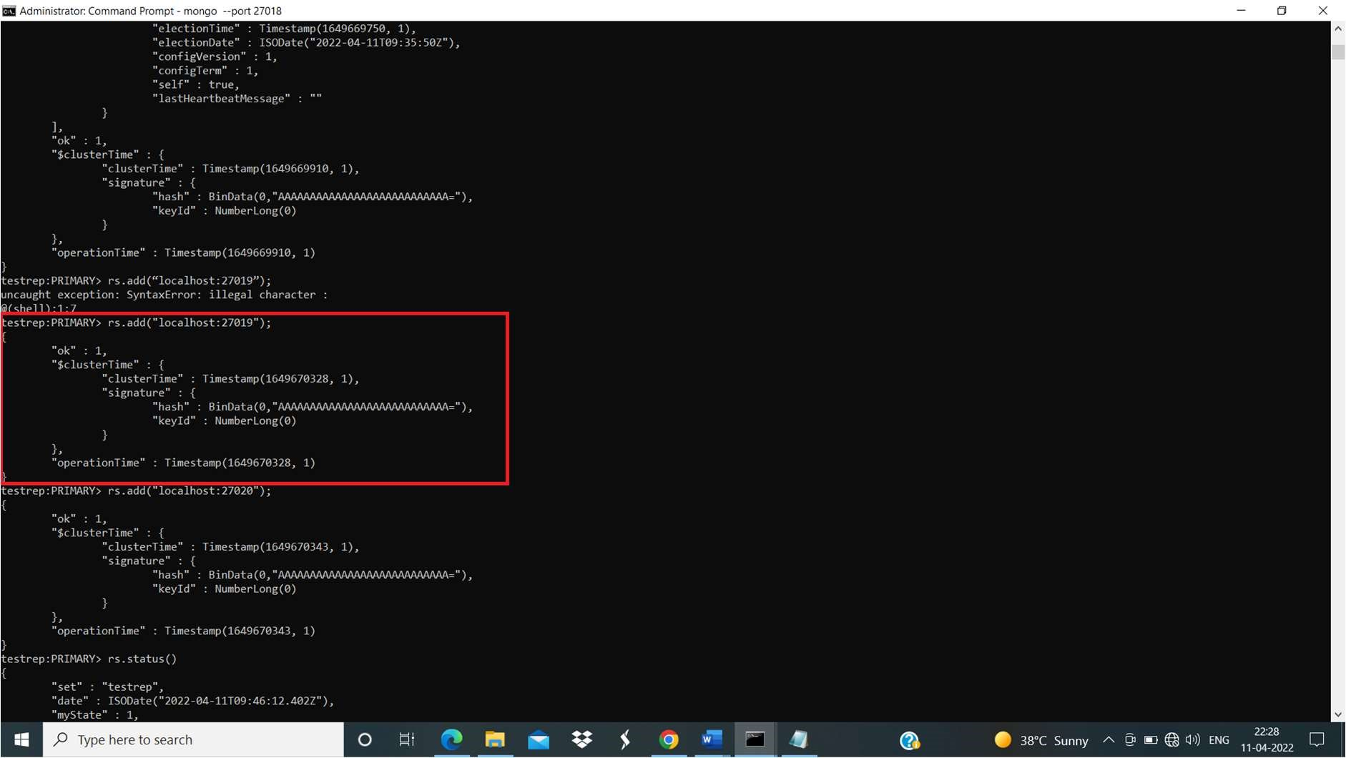

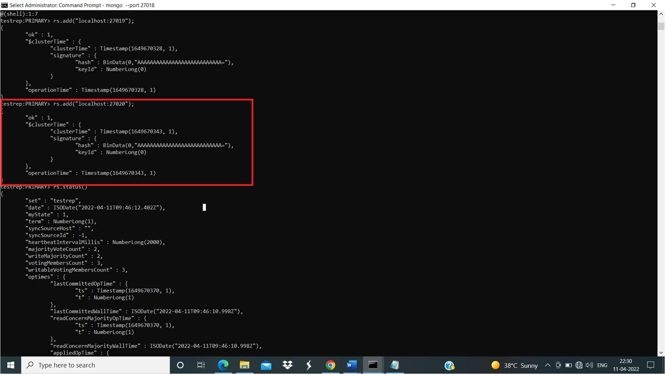

Now to check whether everything is working fine or not we’ll create one collection and check for it in secondary servers.

Step 7:

Create a database named demo1 and collection inside named demo1.On CMD client window of Primary client (port 27018).

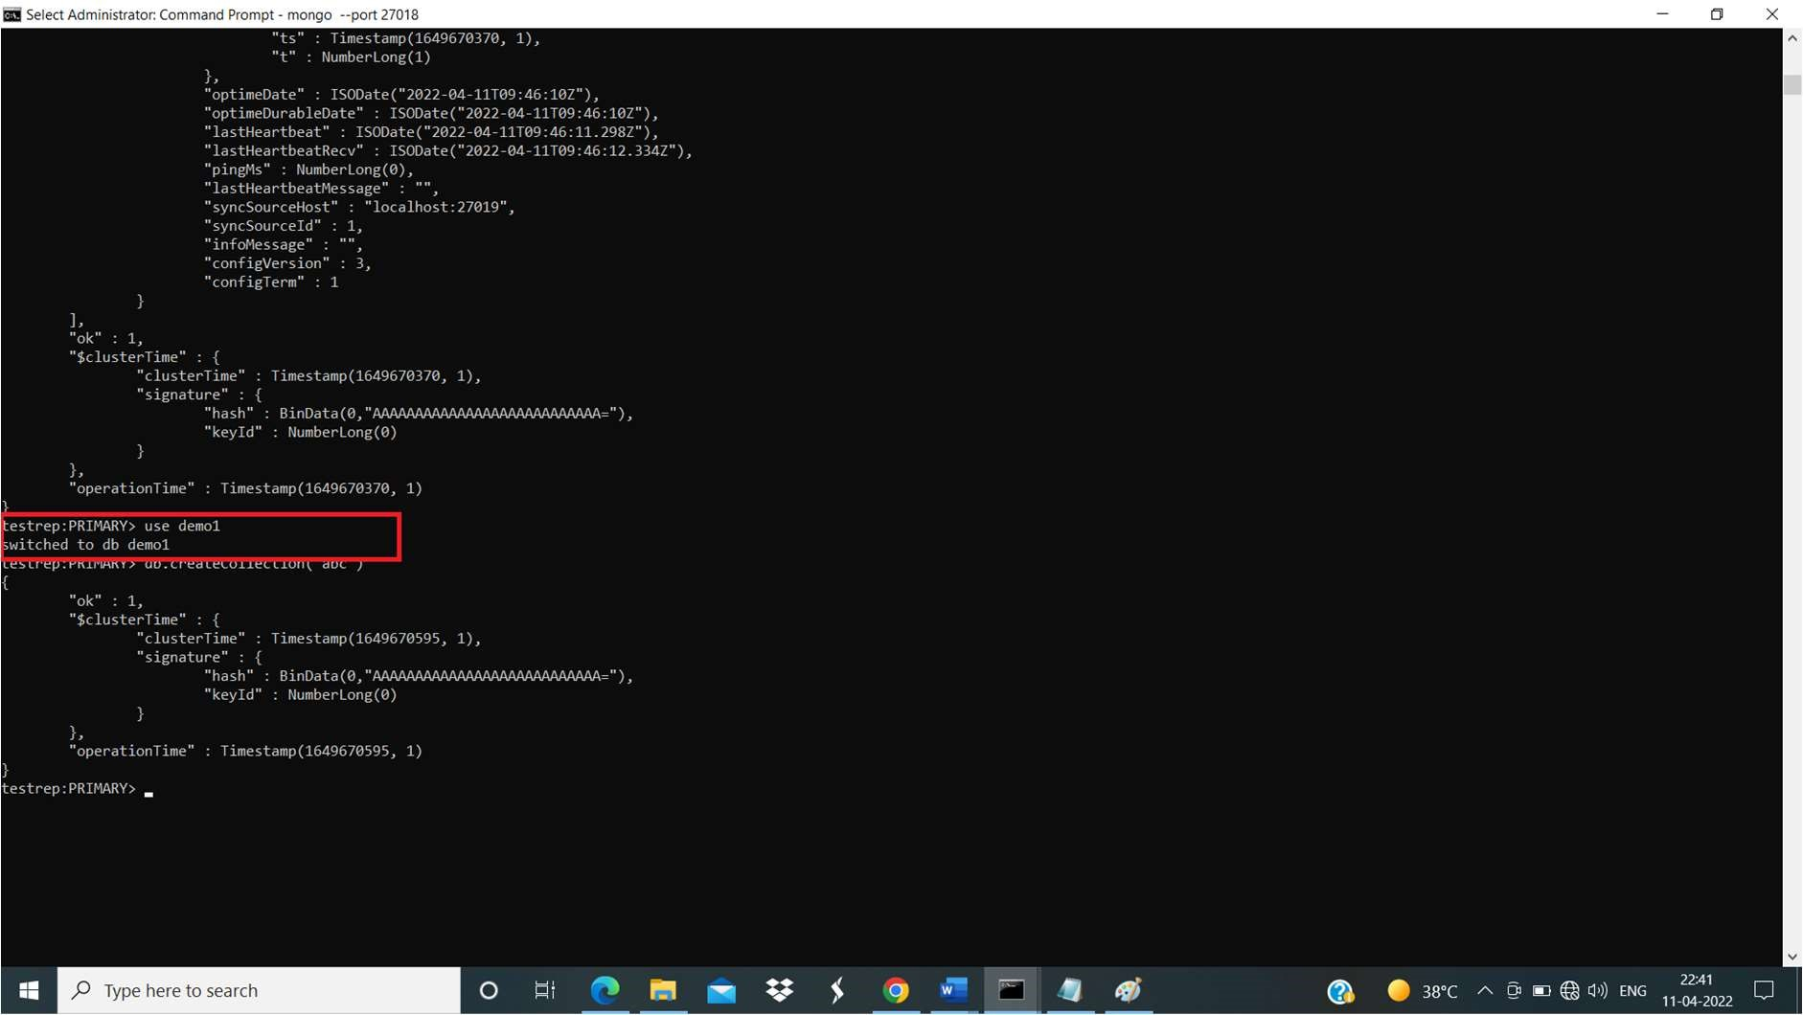

Step 8:

Now goto client window of port 27019( To check whether we can see the database replica over there or not).

First try to execute show dbs directly, it will show error or operation failed!

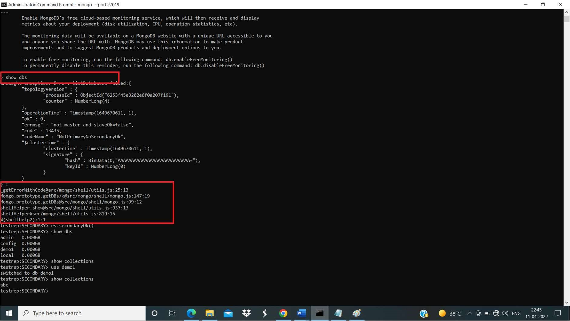

Then to get perfect ouput we need to execute rs.secondaryOk() method.

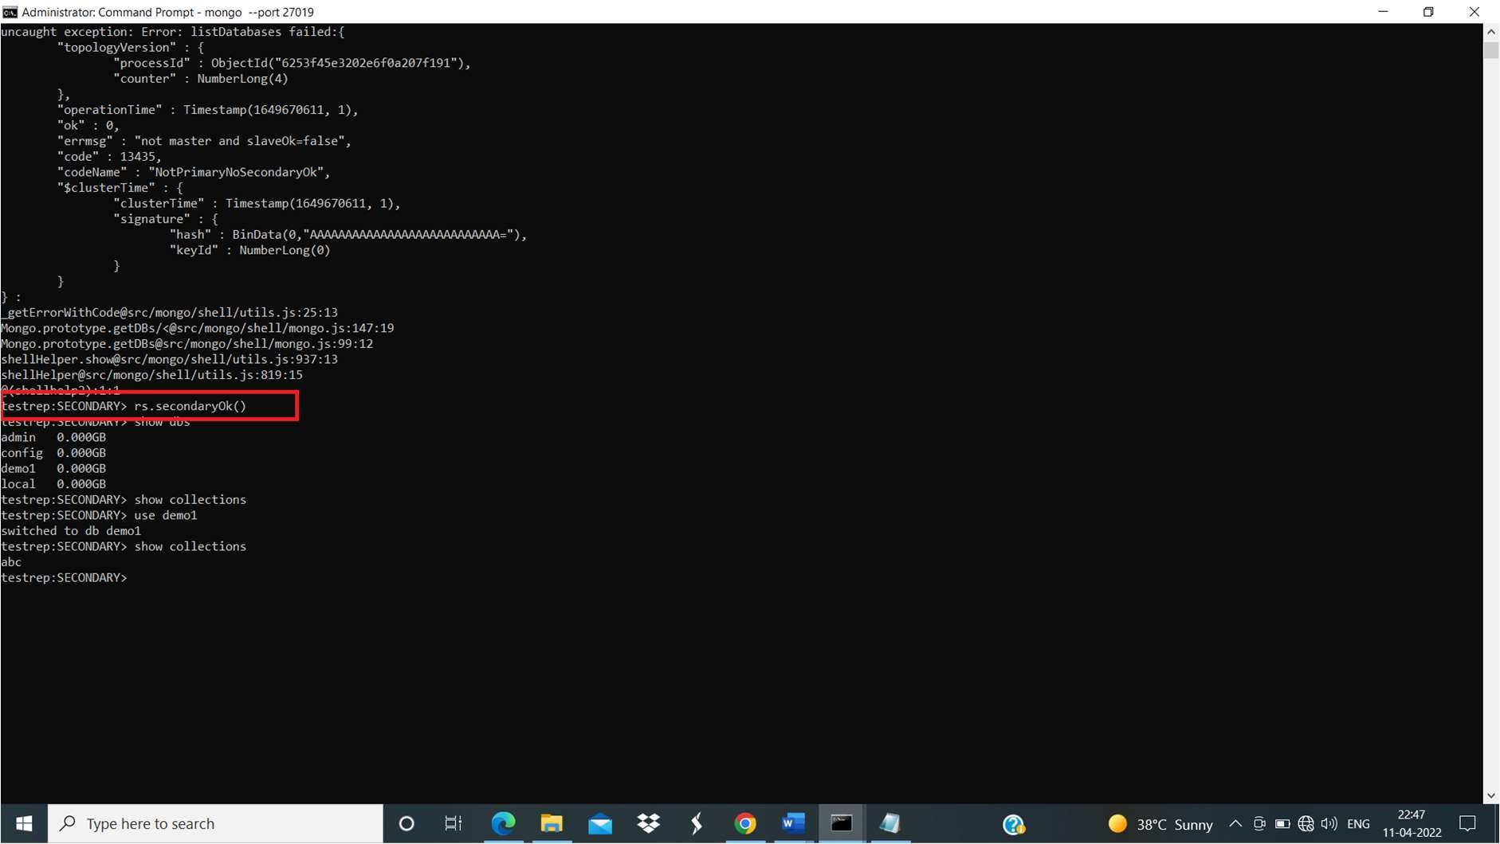

We can also use rs.status() to check status of our servers whether its primary or secondary.

